For the most path prosper was in charge of making the make file

Nwabunor was in charge of making server

And we both worked on the client side of the project

This a quick guide on how to use the program

To use the make file we do make all

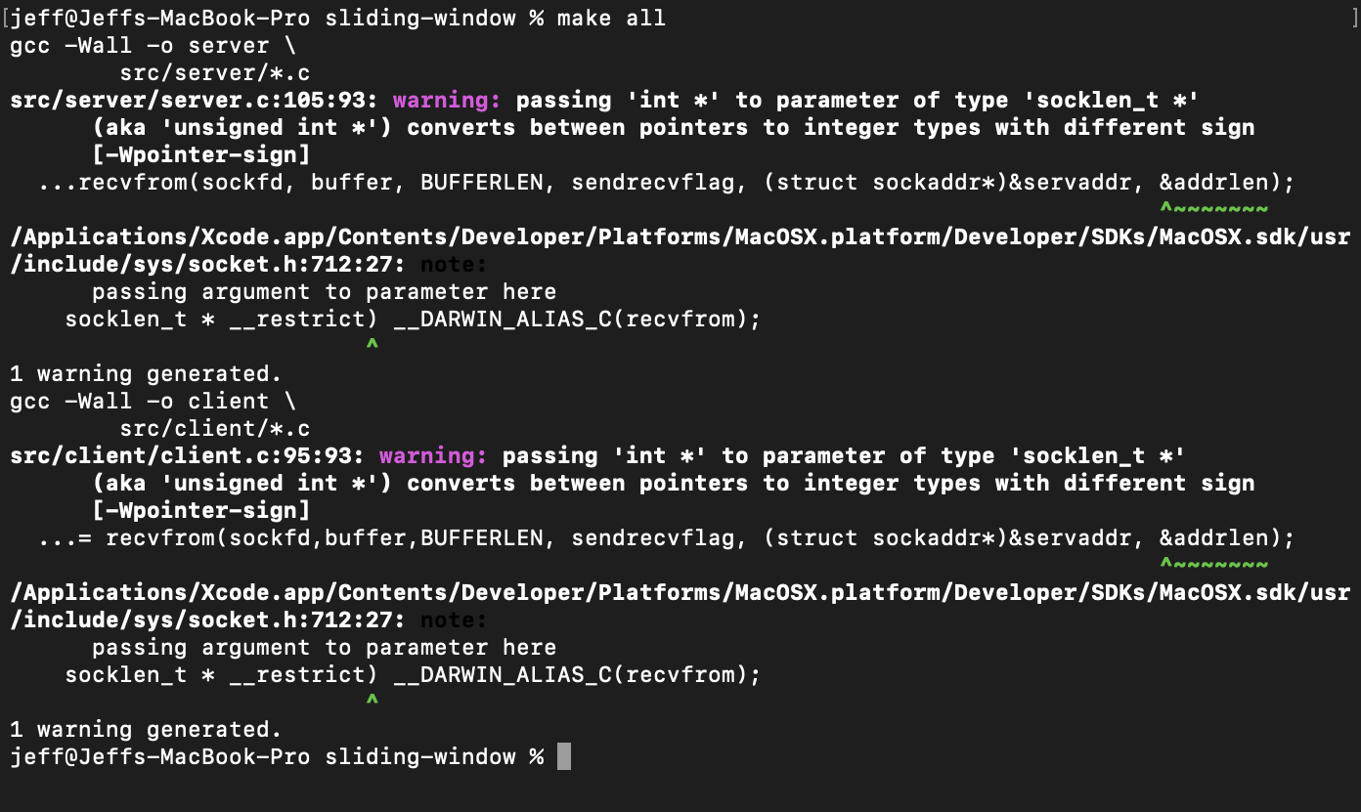

This will make both client(receiver) and server(sender) you can also just do make server and make client to make them individually

To start the server we go ./server

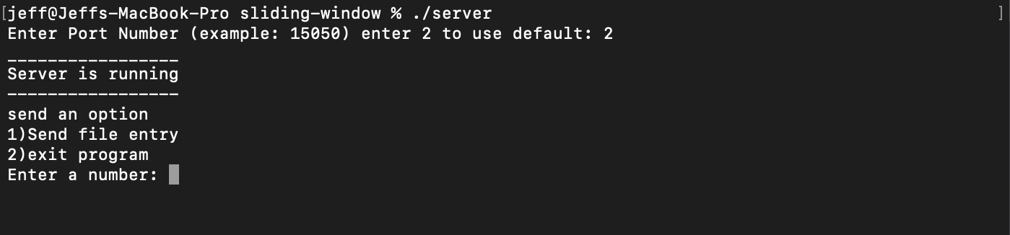

When the server starts you can enter a port number eg 12345 or just type 2 to use the default port number

Then you can type 1 when prompted to start the file sending process

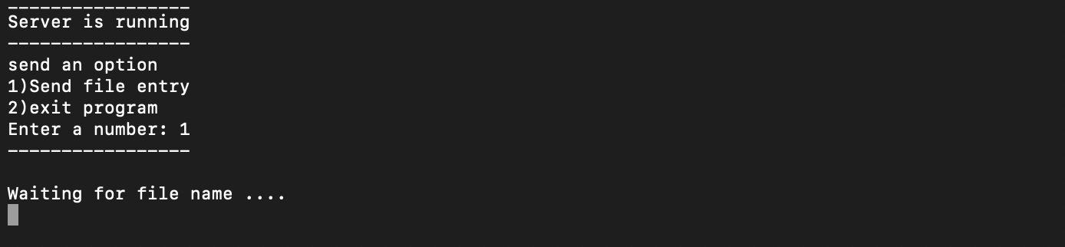

Now go to the client side and run it with ./client

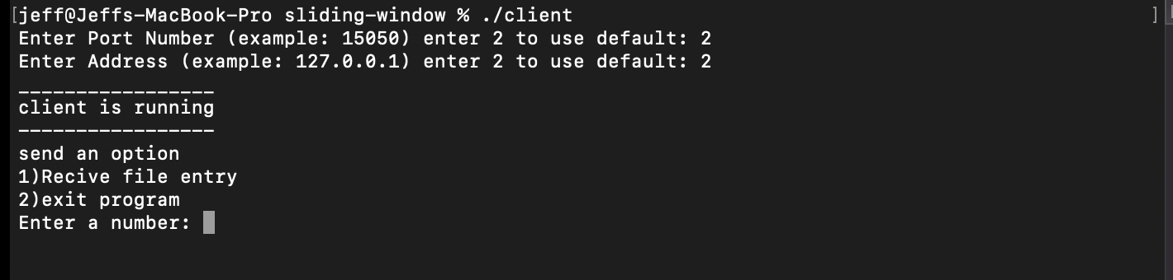

Like the server side you will be prompted to enter a port number but this time you can also enter ip address.

You can select 2 for both options to use the default

Then you can type 1 when prompted to start the file receiving process

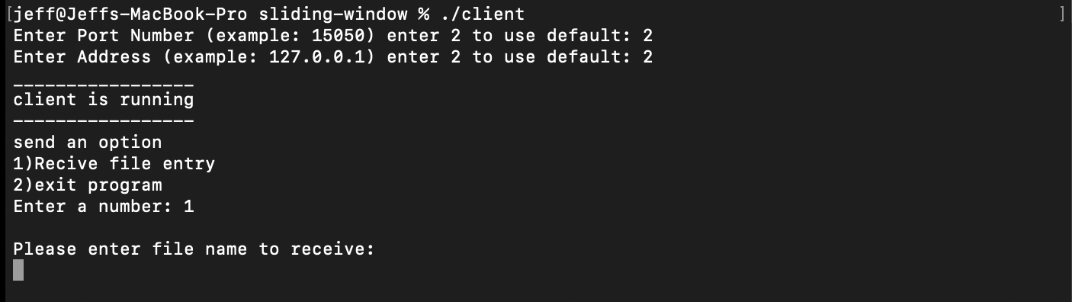

You can type in the file name to get the file details.

There are file stored under the server directory

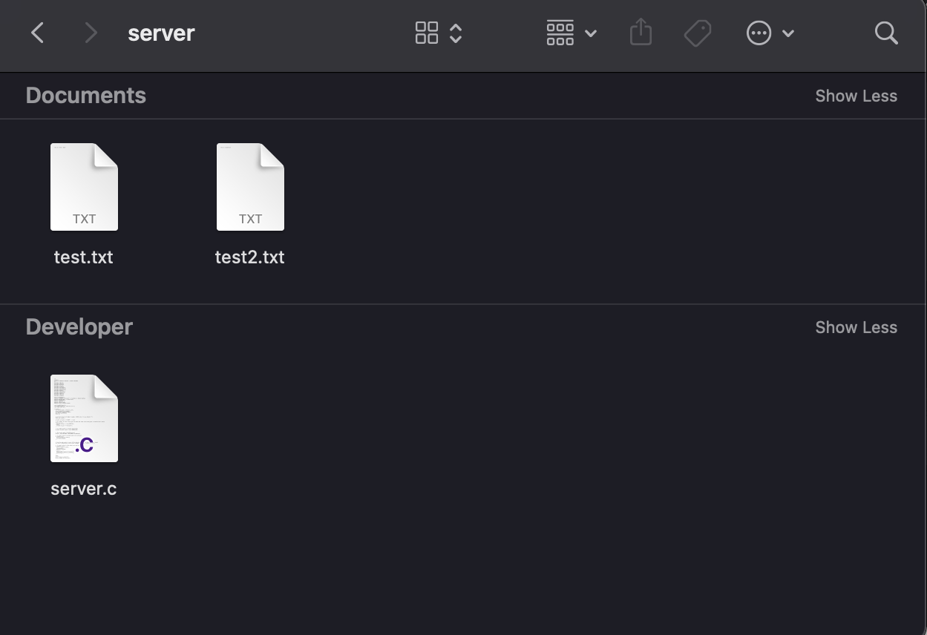

This is where the server gets the files it sends to the client, the client requests one and the

server sends.

Say we want test2.txt on the client we go test2.txt



And the output would be the contents inside test2.txt



On the server side we get the output for acknowledgement

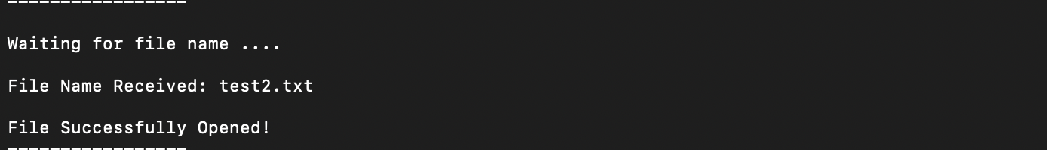

And that's it.

To empty the sliding-window of all the executable that we run we go make clean that that will clean the directory of all junk

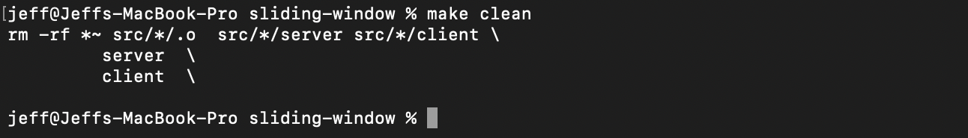

A full server output for 1 file transfer

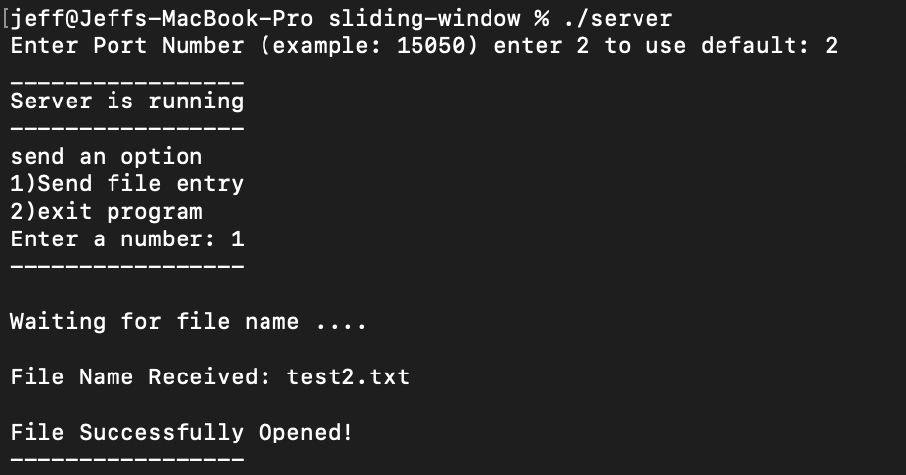

A full client output for 1 file transfer

